Kingswood House Fencing Club

Spring Term Starts Mon 16 Jan 2023
Y4 & New Beginners 12.50-1.30pm
Y5 NB & Intermediate Class 1.15-2pm

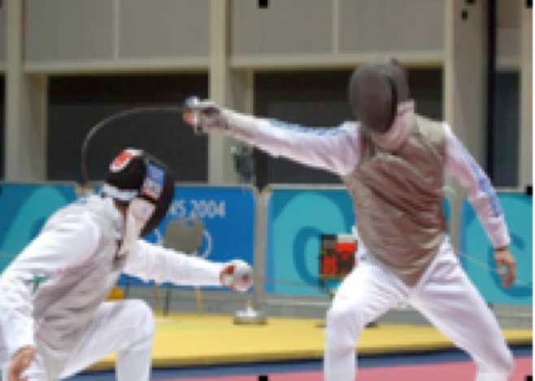

Fencing is an exciting, physically and mentally demanding sport that offers the challenge of combat in complete safety. Fencing exercises a wide range of skills and abilities. It promotes physical fitness and agility, speed and precision, but is also dependent on mental speed and reasoning. Fencing is one of four sports which have been featured at every one of the modern Olympic Games since 1896. Madonna, David Beckham, Tom Cruise all fence as did Bruce Lee.

Age: Dependent on ability but as a guide 9 or above (Y4+).
Classes: Beginners: Group 1: Yr4 New Beginners & Intermediates class 12.50pm – 1.30pm
Group 2: New Beginners & Intermediates class in Y5 and above 1.15-2pm
Y5 intermediates arrive at 1.15pm to get kit on and ready to start at 1.30pm – 2pm.
If Mondays do not suit there is an alternative Wed night option At Blenheim High School with Epsom Fencing Club: New Beginners classes including adults - Starts Wed 11 Jan 2023 – 7-8pm (Adults 14+ 8-9pm) See www.Epsomfencingclub.org

Spring Term Sessions: Mon 16 Jan – 20 Mar 23. Half term is 13 Feb

Health & Safety: Fencing is an active sport and a certain amount of physical contact is part of the sport - if you have any medical concerns, please discuss with coach Nick Payne or consult your doctor.

Clothing Requirements: New COVID19 requirements means minimising sharing of equipment, so intermediates (at least 1 term of fencing) need their own steam kit (mask, jacket, glove, plastron, non-electric foil). We have a hire scheme and some kit can be hired. Students should wear sensible indoor specific training shoes & socks. Stout track-suit bottoms (preferably with zipped or no pockets) or fencing breeches. T-shirt or thin long sleeved shirt. Plastic mask and foil for beginners to start with is supplied.

The Coaches: Nick Payne is ex British No1 and the founder of Sword Fighting International and Epsom Fencing Club.

If your child would like to attend, please complete the attached and return to school (no need to complete if you have previously completed one).
-----------------------------------------------------------------------------------------------------------------------
OLYMPIC FENCING
Kingswood House School Spring Term 2023
Mon 16 Jan – 20 Mar 23. Half term is 13 Feb

Y4 and New Beginners (Y4) 12.50-1.30pm
Y5 and above 1.15-2pm
New Beginners Y5 and above 1.20-2pm (PLEASE CIRCLE YOUR CHOSEN TIME). Click here for online form (or see link at bottom). Form is not needed if you have previously completed a form and your child is returning.

Childs name:……………………………………………DOB:…………..…… Age: ………

Contact telephone:……………………………..………………. Class: …………………

Postcode: ……………………………. Occupation (optional); ………………..………

Medical conditions (of which the coach should be aware) if any:

……………………………

I give permission for my child to attend the Fencing class and agree to have details stored in accordance with GDPR requirements.

Bank Transfer Payment: SFI Barclays Bank 20-29-90 13949486. Please add ‘KHS and name’ as ref.

PLEASE ALSO EMAIL nick.payne@swordfightinginternational.com TO CONFIRM PAYMENT HAS BEEN MADE
Cost: £95 This includes all plastic fencing kit, tuition and insurance. Intermediates will need their own steam (non-electric) fencing kit: mask and foil, plastron and jacket. There may be an option to hire kit (with a paid deposit) each term. Improvers may also start doing electric fencing and will then need a body wire, electric jacket and an electric foil.
Signature parent / guardian: ………...……………………………………

Name - Please print: ………...…………………………………………..

Contact email (for parent):………..……………..…………………………

PLEASE CLICK BELOW FOR WEBFORM IF YOU HAVE NOT ALREADY COMPLETED DETAILS ONLINE OR TYPE : https://fs163.infusionsoft.app/app/form/khs-webform-sep22

