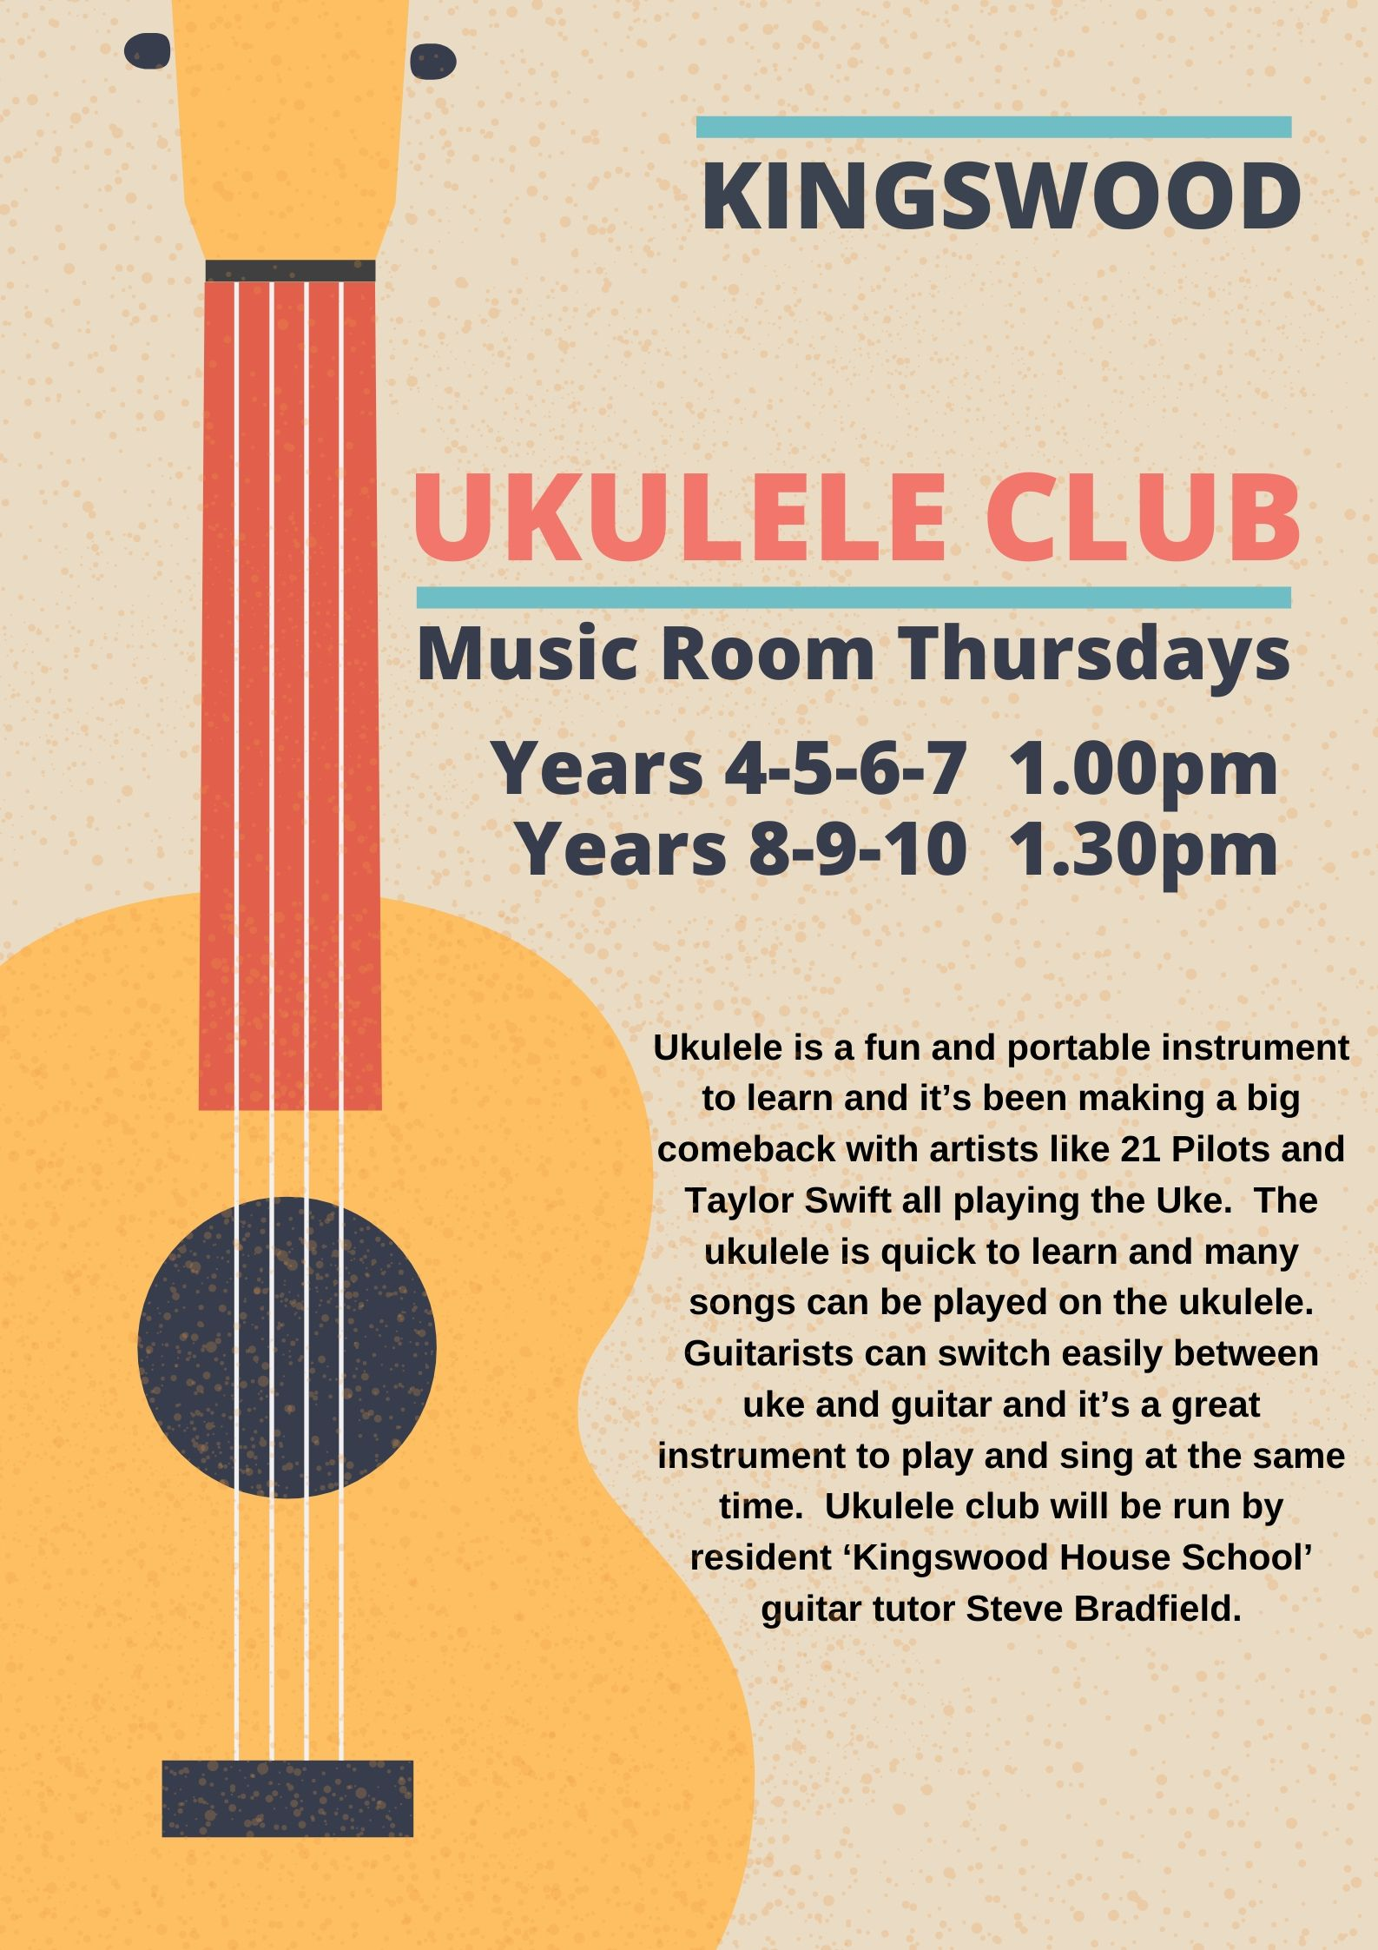

‘Ukulele Club’ Years 4-7 Spring Term 2020
Thursday Lunch times at 1.00pm in the music room.
‘Ukulele Club’ Years 8-10 Spring Term 2020
Thursday Lunch times at 1.30pm in the music room.
Thursday 16th January – Thursday 13th February / 5 Weeks
Thursday 27th February –Thursday 26th March / 5 Weeks
There will be 10 half hour sessions in the Autumn term at £6 each.
Cost £60 for the Autumn term.
Please note that payment is to be made by bank transfer to:
The Guitar Studio, Sort code Sort 20 – 97 – 58, Account Acc 10814490, Barclays Bank, with your child’s surname.
Please contact me via email to confirm your child’s place before term starts and sign and return this form to the school office at the beginning of term. If starting mid-term please contact me for an invoice.
flametofiresteve@gmail.com
----------------------------------------------------------------------------------------------------------------------------------
Name:
Form:
I would like my son to attend Kingswood Ukulele Club
Signed:
Contact Email
----------------------------------------------------------------------------------------------------------------------------------
Students should bring their own ukulele and a good starter is either a Brunswick Soprano in Blue £35

https://www.yamahamusiclondon.com/BU2S-Soprano-Ukulele-Blue/pidLBRU2SBLSOPBLU

Brunswick Soprano in Natural £30

https://www.yamahamusiclondon.com/Soprano-Ukulele-Natural/pidLBRU2SNSOPNAT

Or a Concert size for larger hands £39

https://www.andertons.co.uk/acoustic-dept/folk-bluegrass-instruments/ukuleles/mahalo-java-concert-ukulele-natural-satin
https://www.gear4music.com/Acoustic_Guitars/Concert-Ukuleles

