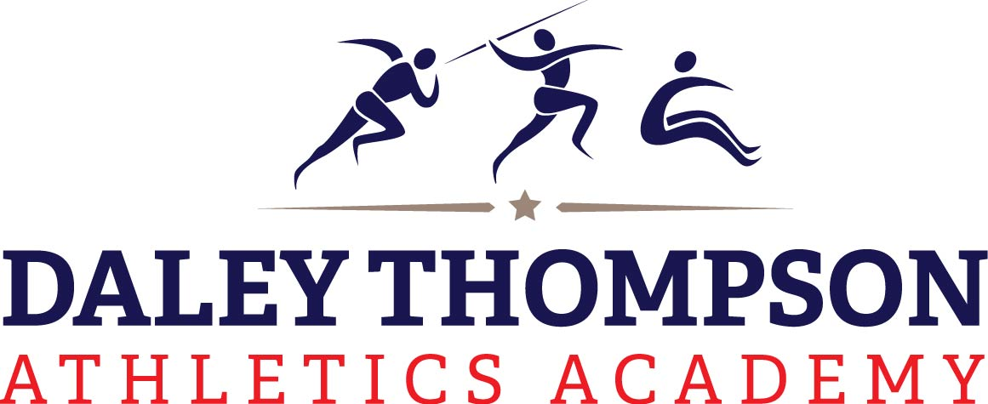

Daley Thompson’s Run, Jump, Throw Academy
This Academy has been developed by Daley Thompson and Kate Staples and is run by their hand picked coaches. This academy is taught purely through fun game play and is designed to teach fundamental and motor skills needed in all sports in a fun environment as well as key athletic skills.
The Academy will develop the following:
- Running Efficiently
- Speed Endurance
- Jumping activities
- Throwing skills
- Early principals of learning to jump, throw and run
- Agility, balance and Co-ordination.
- Plus, Lots of Games

Classes commence: week of 13th January 202

This will run on the following day:

Tuesday 3:45-4:30 (£99)

Please enter the following links into your URL bar to register
https://www.participant.co.uk/asg/KingswoodW

If you have any questions please do not hesitate to contact Ollie Ruttle on 0333 6000121 /07920058673
Kind regards
Daley Thompson Academies LTD.

Company number: 8718169 company incorporated in England and wales

